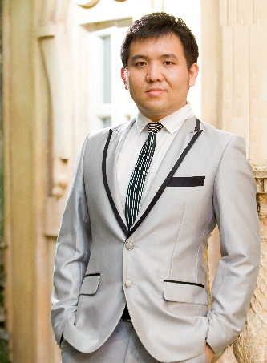

Name: ZHANG MINGWEI
Mobile: 65-97998378(Singapore)
1-909-2867862 (US)
E-mail(Prefer): mwzhang@outlook.com
Personal Portal: www.mwzhang.me

All personal information below mentioned is only for your company only.

DO NOT forward to any other party for any purpose.
Thanks.

Milestone.
Y1998-1999 China
Setup my own business (20 PCs Internet café).1st Bucket Gold
Y2000-2003.Singapore Nanyang Polytechnic
Nanyang Polytechnic(NYP)
Diploma in Manufacturing Engineering
Y2003-2004 Singapore
Join Mentor Media
Working as Process Engineer
Y2004-2008China/Shenzhen
Work in Mentor Media
Working as Process/IT Engineer
Y2009-2011.7China/Shanghai
Work in Mentor Media
Working as IT/Engineering Manager
Y2011.7-2016.12 Singapore
Join HP (Hewlett-Packard)
Working as SME in WW Process and Capability Team under technology operation
Y2013-2015. Oxford Brookes University
Bachelor of Science (HONS) IN Information Systems & Software Engineering.
Y1995-1998.Jilin High School
High School
Piano Grade 9
China University Exam 512.3
Y2017.2 –2018.8USA
Mentor Media California
Working as Tech Lead in IT/Engineering
Y2006.Microsoft Pro. China
MPC (Microsoft Professional Certificate)
Y2018 9 – NowSingapore
FTDI
Working as IT Manager in (IT/Sales Operation/BI)
Y2019-2020.11 Coventry University
Master of Science in Engineering Business Management
[Education/Training]
[Professional Experience]
Married in Shanghai - 2009.
I, Born in 1979.
1st Son Born in Singapore- 2014
Timeline
To be Continued

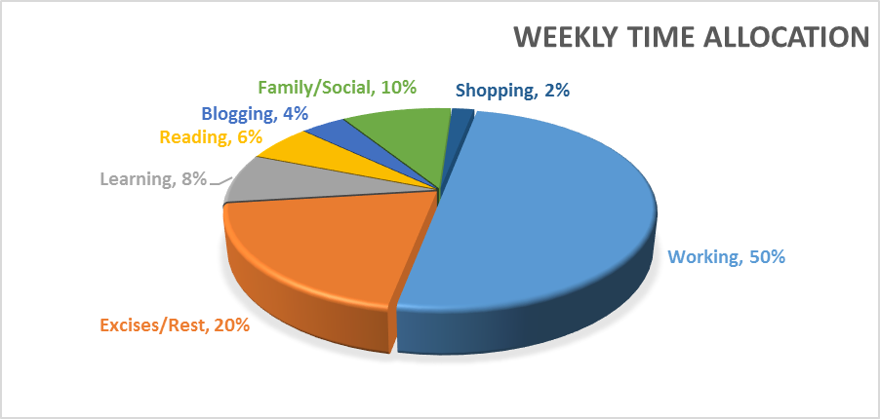

Skillset Self-Evaulation

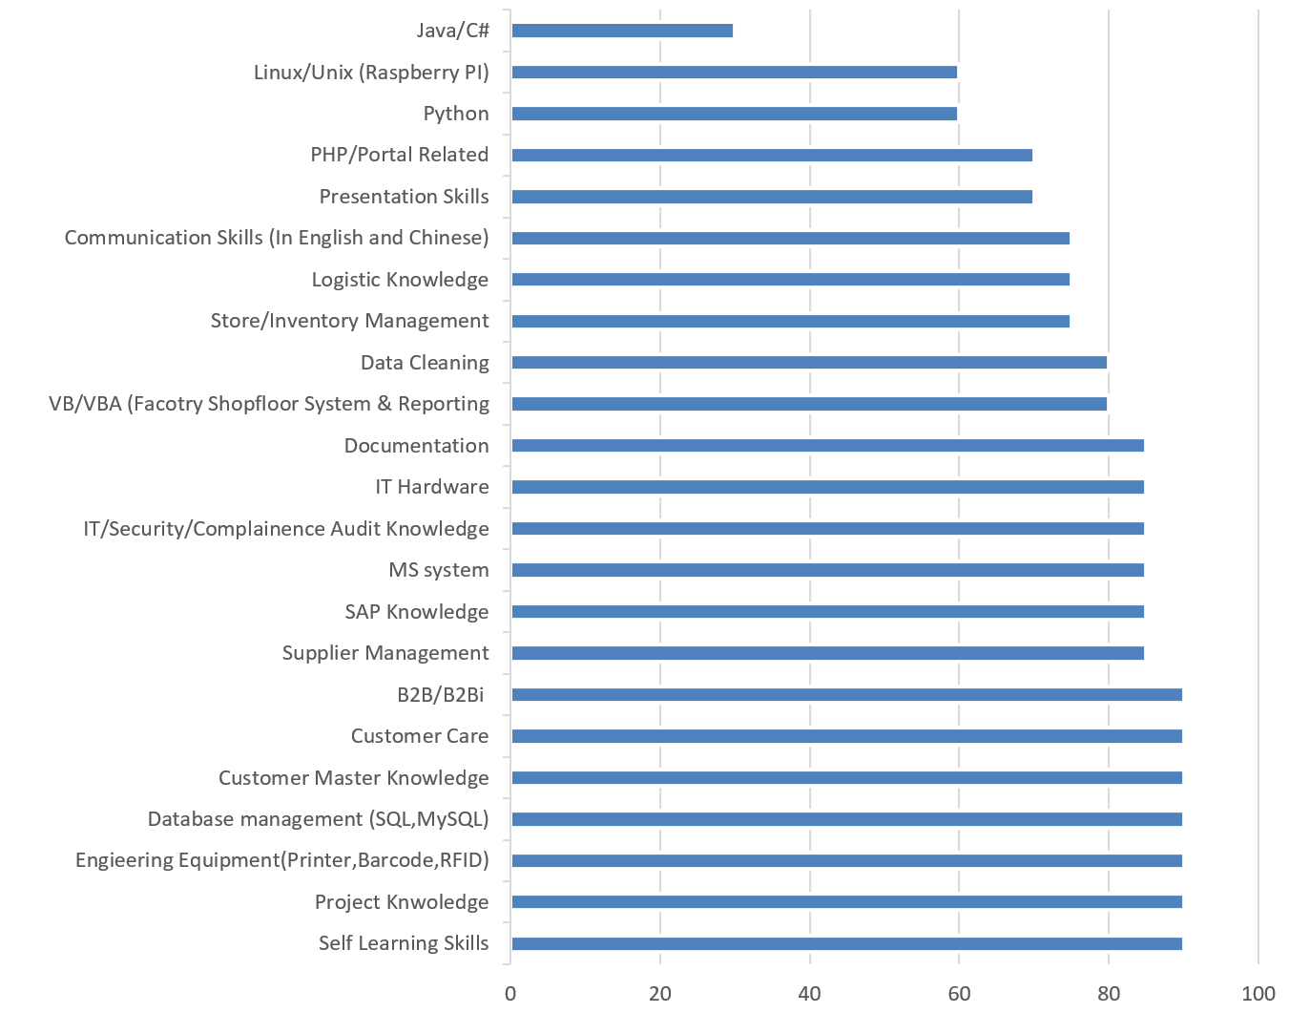
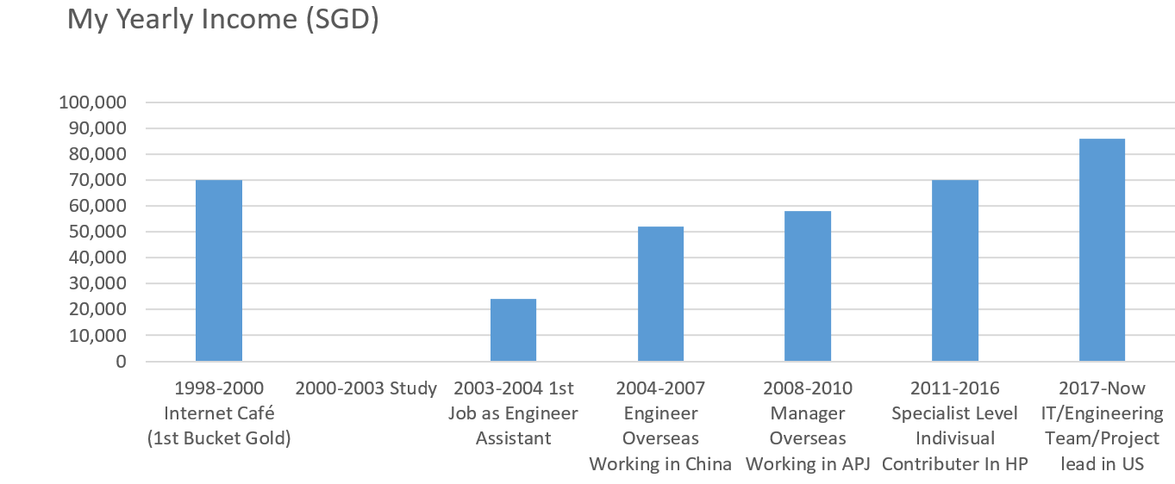

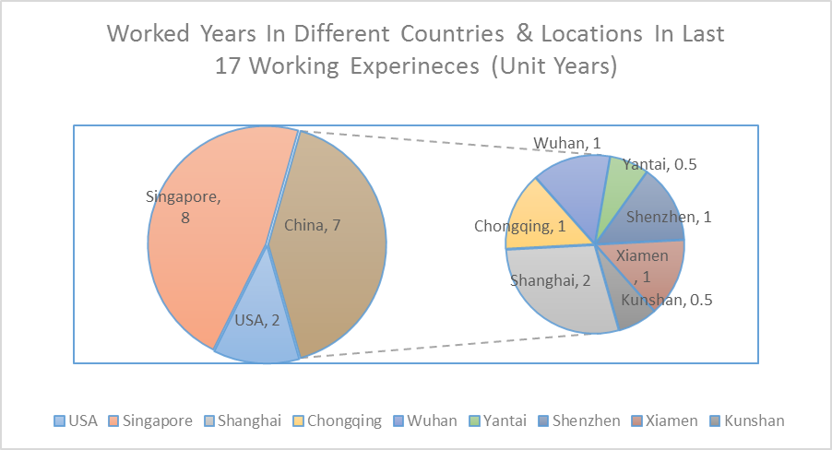

If I am the person you are looking for, you can refer to below information for further clarification or drop me an Email @ mwzhang@outlook.com.

【Basic Info.】

Name: ZHANG MINGWEI
IC/Passport No: S7977757I
Gender: Male
Birth: 21-July-1979 Citizenship: Singapore
Nationality: Singapore Citizen Race: Chinese
【Contacts.】

Mobile: 65-97998378(Singapore)/ 1-9092867862(US)
Email（Prefer）: mwzhang@outlook.com
Personal Web Portal: http://www.mwzhang.me

Address In Singapore: BLK291C #14-254 Compassvale Street, S543291
【Objective.】

- Result-oriented and IT/Tech background with 7 years working experience as Process Engineer and system analysis and 3 years Project Manager /SME Experience in world-class IT leading corp.
- 1 year Engineering Manager experience to pull whole team synergy to contribute for company
- Always looking for technical method to analyze and improve business processes. Ability to work well both independently and collaboratively. Able to work in a fast-paced and dynamic environment.
- Good learning skill in new knowledge with creative, productive thinking.
- Deeply understand customer requirements and nurturing client relation-ship. Experienced in Microsoft, HP Project management and Process Design/improvement.
- Save each single cent for company. Company business is my own business.
- Keep learning through the whole life.

【Capability.】

- Mother language level in Mandarin both speaking and writing;
- Business professional in English both speaking and writing;
- Intermediate Level in Japanese both speaking and writing;
- Good Manufacturing Engineering Knowledge, such as Time study, Process flow design, New Product Intro, Production line balancing, Inventory control. QA, GP and Lean6;
- Good Experience in new factory setup, such as recruitment, equipment purchase & setup, company license, tax or export & import license application, Factory facility renovation, especially in system security or factory security, staff Training, system deployment and BOM setup etc;

- Good Skill in all different kinds of shopfloor system, web system and database design, such as, VB/VBA, PHP, SQL, MySQL, MariaDB etc. Used to be involved HP SFNG, SAP/Fusion, SFDC, OIS, OSS, Beacon system training;

- Rich Experience in the factory hardware and IT equipment. Zebra Label Printer (enable to disassembly and assembly the whole Zebra printer.), PLC production line, 1D/2D Barcode scanner, factory camera visual system;

- Good Operation Experience in supply chain, call center, fast fulfillment and logistic;

- Good Security Sense for all compliance project; used to work on the Microsoft Security Related Project;

- Good Experience in handling all kinds of audit, such Microsoft compliance audit, Microsoft security audit. HP ESD Engineering Audit;

- Good Study and Deep Dive capability, such as Payroll system started from “0”, and hands on within 2 months;

- Able to talk to customer and fully understand customer requirement and develop system or process to win customer deal;

- With good IT hardware knowledge, enable to follow instruction to assembly hardware and setup the APACHE server, VPN, Email Server, FTP/SFTP server, file server, and build up secure office networking. Write simple shell script to manage the Linux server;

- Good Habit to write “how to” documents, learning journal in work and real life. Refer to my personal Blog http://mwzhang.blogspot.sg/

- Project Management Skill with LSS Green Belt Certificate;

- Familiar with those China ODM and China Government officer;

- Familiar with US working and business environment;

- Business Traveling Adaptation;

【Education.】

Year 1987- Year 1993 Jilin Long Tan No.2 Primary School

Year 1993- Year 1995 Jilin No.6 Junior School

- Piano non-professional Degree 9

Year 1995- Year 1998 Jilin No.12 High School

- Chinese college entrance examination 512.3. (University Degree line 506 in1998).

Year 1998 – Year 2000 Jilin Overseas Foreign Language Training Institute

- TOEFL 575
- Setup my own business, (20-PCs Internet Café).
  - Learn HUB Technology
  - Diskless workstation
  - Windows 95

Year 2000- Year 2003 Singapore NanYang Polytechnic School

- Diploma In Manufacturing Engineering
- Specialized in Automation System Design and Plastic Module Design
- Participate the Singapore Robotic Games (Y2003), independently working on Sumo Robot design
- Join Nanyang Polytechnic Chinese Culture club
- Form live band (Mercury) in Sanbawang CC, and have an chance to perform in Singapore President Tony Tan birthday party.

Year 2013- Year 2015 Oxford Brookes University

- BACHELOR OF SCIENCE (HONS) IN INFORMATION SYSTEMS AND SOFTWARE ENGINEERING
- Final Year Dissertation is e-Bidding system.

Future Plan for Education Master of IT in Business - Service Sector Analytics (MITB-SSA)

【Professional Experience.】

Year 2003- Year 2004 Mentor Media Singapore

- Employed as Process Engineer Assistant, Training in Singapore about Microsoft P&P and HP related system, assist Process Engineer in Process Design and system troubleshooting, Created VBA report to improve production output.24 hours support production system as system analysis. Report to Chief Engineer directly.

Year 2004- Year 2005 Mentor Media Songjiang & Kunshan

- Overseas working intendedly in China as Process Engineer, Work with cooperate team successfully Setup Mentor Media Songjiang which is mainly support Acer and Mentor Media Kunshan Branch which is mainly support DELL.
- Design ESD Room as HP requirement and pass HP audit.
- Report to site operation manager directly

Year 2006- Year 2007 Mentor Media Shanghai

- Setup & Training Mentor Media China site HR Payroll System and implemented to all China Sites. At the same time, Involve design and setup the DELL IP management system. Get good comments from DELL and ODM. This system helped OEM managed COA in ODM factory. Involve MS POD system upgrade. Propose “Cell concept” to HP CPMO projects and win good comments.

Year 2008- Year 2009 Mentor Media Yantai

- Setup Mentor Media Yantai Branch which is support Foxconn, Obtain 5-years service award. And independently develop factory shop floor system for MS project and HP CPMO project.
- Involve Jabil bidding project, Assess Jabil operation and process, provide the accurate report for management quote decision.

Year 2009-Year 2010 Mentor Media Chongqing

- Setup Mentor Media Chongqing Branch which is support HP Chongqing Project .Promoted to Assistant Engineering Manager, Report to Engineering Director in Singapore.
- Working with HP US Directly, DB Shankar and Microsoft to setup the MS COA fulfillment process.

Year 2010-Year 2011 Mentor Media Shanghai & Wuhan

- Involve HP SFNG system setup.
- Gemalto SIMS card packing project.
- Successfully setup Mentor Media AR Co-location project in Foxconn WuHan Factory.
- Involve Kitting material inventory control project
- Promoted to Engineering Manager Cover the whole China Region, Report to MM China VP Directly.

Reason to leave Mentor Media:

Have to go back to Singapore stay in order to maintain the Singapore PR status and want to obtain Singapore Citizenship.

Year 2011 - Year2012 Hewlett-Packard Asia Pacific (Singapore)

- SME (Subject Method Expert) in Customer Account Setup Area.
- Customer setup process Re-Engineering. Manage HP contractor improve TAT from 9 days to 3 days.
- Involved CSFONLINE-Customer Setup Form online Project
- Master Data Migration Project

Glocal Singapore Company (Non-profit Part time work)

- Business Analysis Consultant (Project Base)
- Working on the e-biz solution(MyBino is Portal)

Year 2012 – Year 2013 Hewlett-Packard Asia Pacific (Singapore)

- SME (Subject Method Expert) in OTC- Order To Cash
- Involved Partner Agent/ Partner Direct/ DMFI customer Process Re-engineering Porject as Project Manager
- SME (Subject Method Expert) IN Tech Direct system. Take an escalation lead to drive the root cause analysis.
- CSFONLINE system Migration from Local server to HP Cloud Service (Linux platform and MySQL Database)

Year 2013 – Year 2014 Hewlett-Packard Asia Pacific (Singapore)

- SME (Subject Method Expert) in B2Bi – B2B integration. Actively work with customer to involve the customer punchout catalog and PO business to business process design.
- Green Belt Project in Order fall out management.
- TS Project as Tech Lead

Baiwei Network Solution China (Non Profit -Part time work)

- Business Analysis & System Structurer Engineer
- Working on the Programming Trading Solution(Python)

Year 2015 (Jan – Aug) Hewlett-Packard Asia Pacific (Singapore)

- SMO (Split Management Organization) Role For B2B and B2Bi (Night Work)
- B2B and B2Bi SME Supporting Role (Day Work)
- Customer Master setup process SMO work

Year 2015 (After Aug) Hewlett-Packard Enterprise Asia pacific (HPE)

- OIS SME Role
- B2Bi System setup and ARIBA Admin for APJ
- AOE (Automated Order Entry) Project Manager Scoping work with IT Developer
- System support (T2 Level)

Year 2016 (After Jan) Hewlett-Packard Enterprise Asia pacific (HPE)

- H3C Project (SME Role)
- AOE Project (Deployment for APJ)
- System Support (T2 Level)

Co-founder (Leanring Anything)

- Business Analysis & System Structurer Engineer

Reason to leave HPE

Overseas Working opportunity;

[Good Communication and Learning.]

Regular 1:1 review with Personal Mentor and Manager

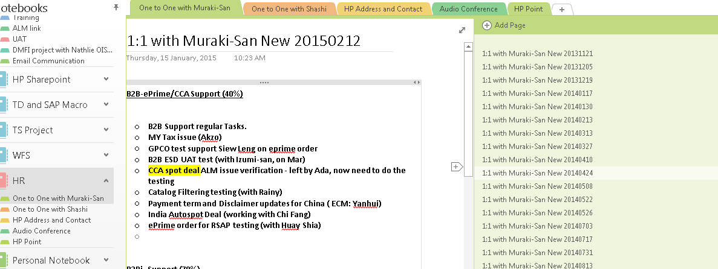

“How To” Knowledge Documentation
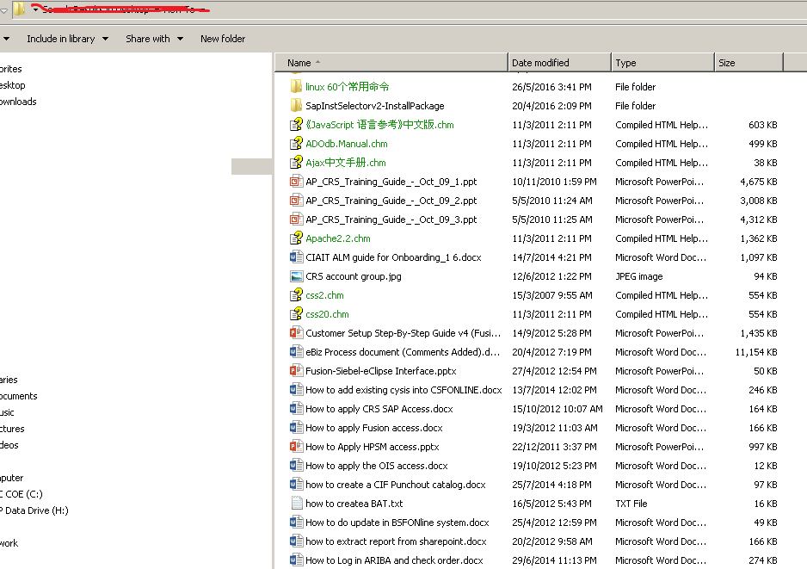

Personal IT knowledge Blog

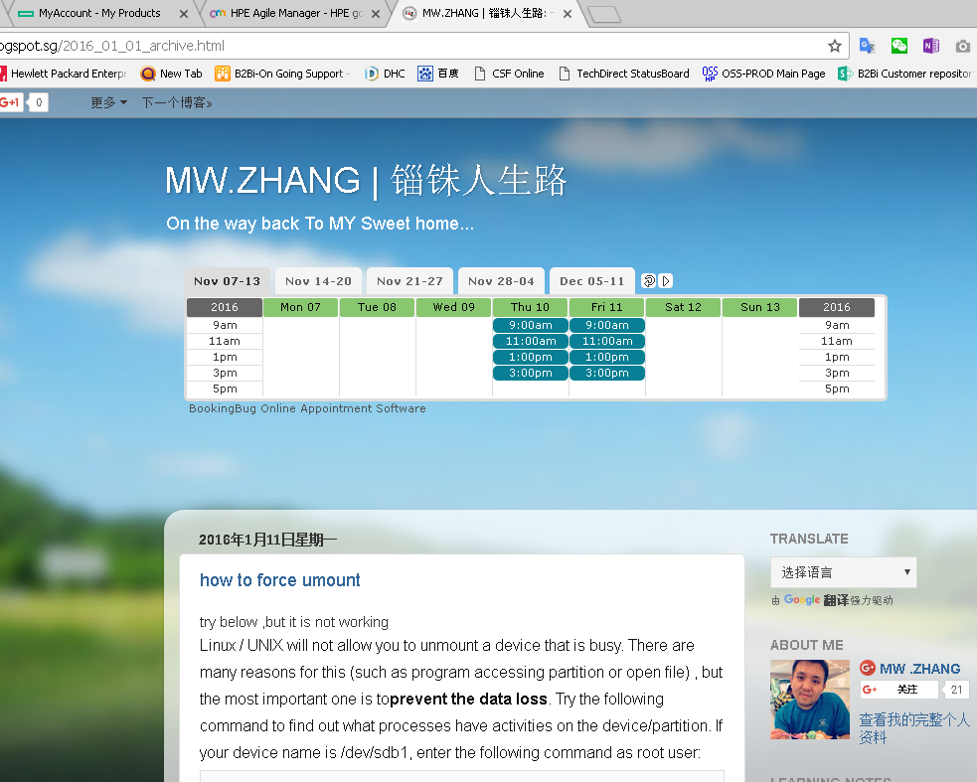

【AWARD & RECOGNIZATION.】

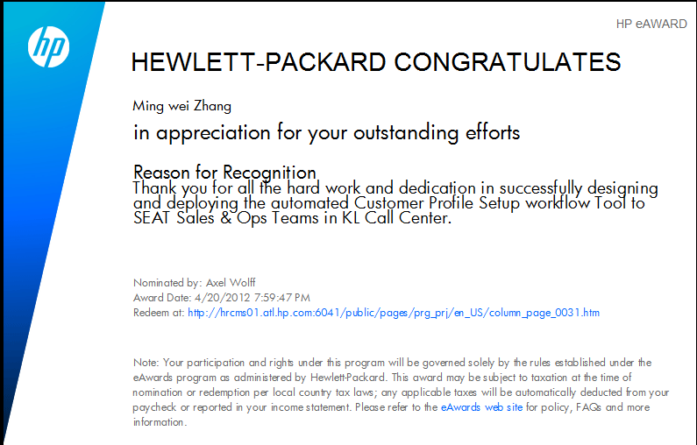

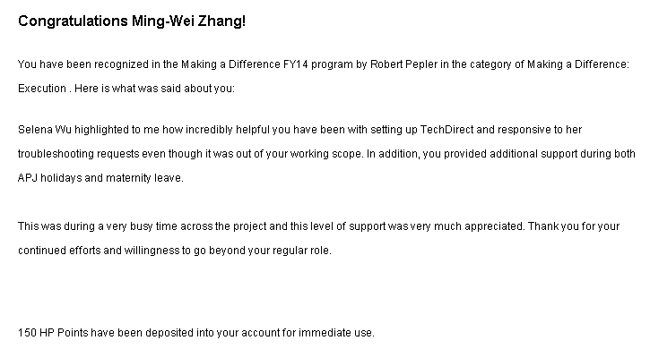

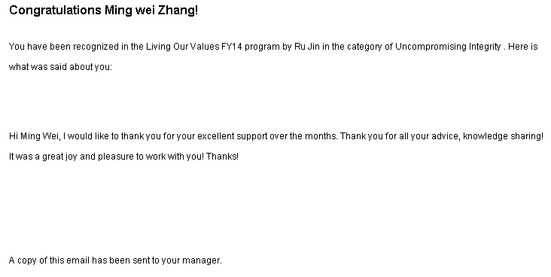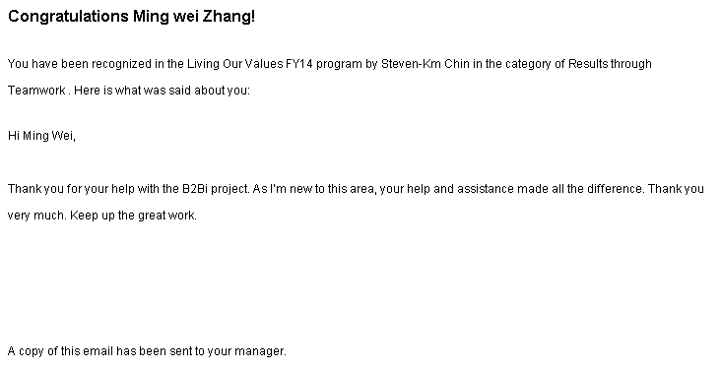

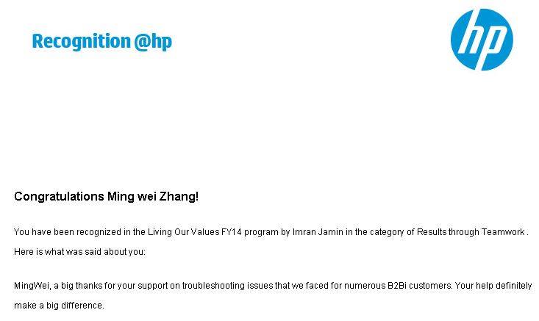

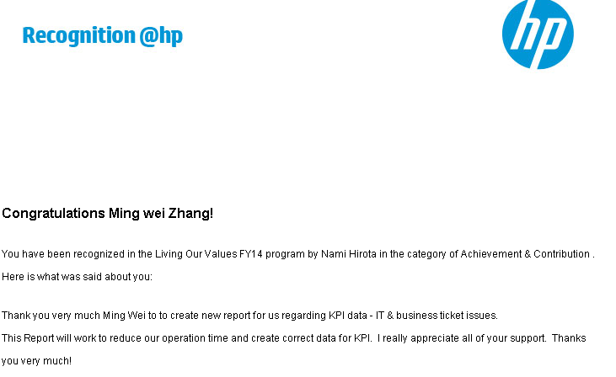

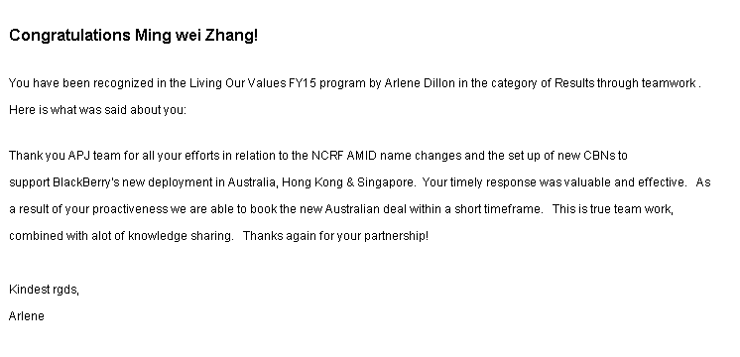

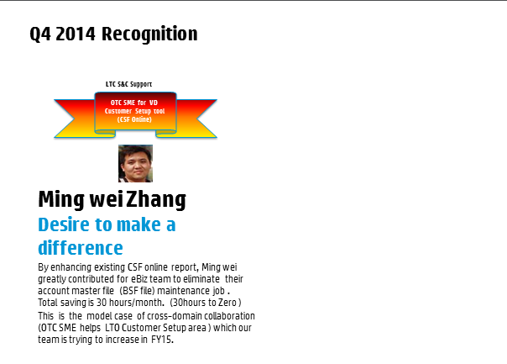

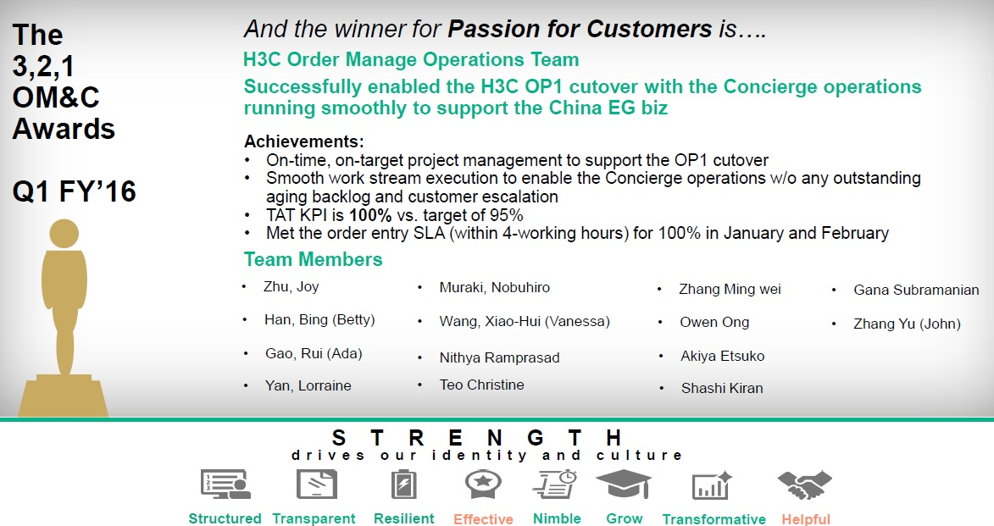

More…..

【Reference URL.】

- MyBlog: MW.Zhang | 锱铢人生路
  - http://mwzhang.blogspot.sg/
- MW.Zhang Photograph Work | 个人摄影作品集
  - http://photo.163.com/ilovezmw/#m=0&p=1
- MW.Zhang LiveBand Performance | 本人乐队表演
  - http://www.youtube.com/watch?v=NTfeaQIyBzE
- MW.Zhang Piano Clips | 钢琴练习片断
  - http://www.youtube.com/watch?v=jEQq_JFNVag
- Guitar Play | 吉他练习
  - http://www.youtube.com/watch?v=wlrwLkPIYtQ
- MW.Zhang Music Recording and Post Processing for my wife | 音乐后期录音处理
  - https://soundcloud.com/ming-wei-16/the_moon
- PHP Portal Design | PHP网站设计作品
  - www.lillybellesg.com
  - www.mybino.com

------END------

